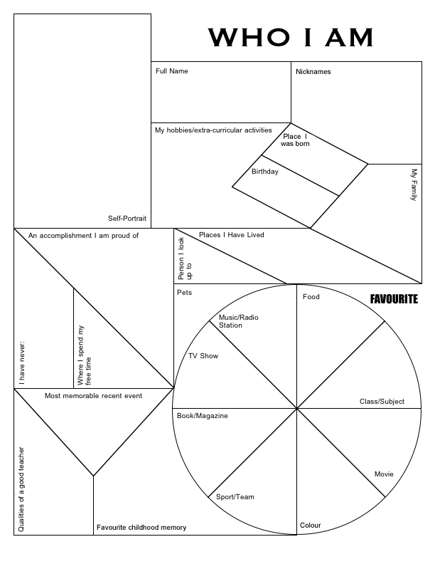

**color**

**Favorite childhood memory**

**Favorite**