Chapter One
The Human Body: An Orientation

Lesson Objectives:
By the end of this chapter, you will be able to…
- Describe the different levels of organization in the human body.
- Describe anatomical position and use the descriptive and directional terms that refer to body structures, surfaces, and regions.
- List the regions of the body and the localized areas within each region.
- Identify body cavities and the organs found within each.
- Define homeostasis and describe its significance.
- List the characteristics of life.
- Describe the components of a negative and positive feedback loop and explain how each helps to maintain homeostasis.
- Discuss the key historical events in the development of anatomy and physiology.

- Overview
- Anatomy:
  - “__________________________________”
  - _________________ of body parts.
  - Means “______________”
  - Dissection of _____________________ is the basis for understanding the structure of the human body
- Physiology:
  - “_________________________”
  - ___________________ of body parts.
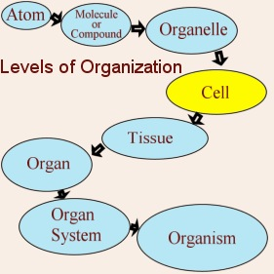
  - What these body parts do and how they do it.
  - Means “_________________________”
  - Much of the knowledge of physiology is gained through ______________________
- *A & P are very closely related – function is closely related to _____________ and _____________
- Essential Concept: The Hierarchy of Structural Organization
  - Chemical:
    - _____________ combine to form molecules.
    - Different types of molecules:
      - small _________________
      - small _________________
      - ______________________
      - ______________________
      - ______________________
      - ______________________
  - Cellular:
    - Cells are made up of ___________________.
    - _____________ and organelles are assembled from various molecules.
    - ***_____________ – the basic structural and functional units of the organism
    - Cells are specialized for particular _______________, e.g., muscle cells are specialized for contracting
    - Cell _________________ are sub-compartments with specialized tasks
  - Tissue:
    - Tissues consist of similar types of ________________.
    - Groups of different cell types cooperate to perform specific functions.
  - _____________________:
    - Two or more different tissue types are organized to perform specific functions.
  - Organ System:
    - Organ systems consist of different ______________ that work together closely and cooperate in a related function.
  - Organism: (Human Being)
    - The human organism is made up of many _______________________.
    - All of the organ systems working together to maintain life constitute the living organism
- Characteristics that make life unique
- _____________________:
  - Self initiated change in position
  - Motion of internal parts
- __________________________ :
  - ______________________
  - Ability to sense changes within, or around the organism
  - React in response to surroundings
- _____________________:
  - Increase in body size
- ______________________:
  - Parents produce offspring / producing new individuals
- ______________________:
  - Obtaining oxygen (O² ), using it to release energy from food substances, and getting rid of wastes
- _______________________:
  - Chemically changing (breaking down) food substances
  - Getting rid of wastes
- _______________________:
  - Passage of digested products (food substances) through membranes and into body fluids
- _______________________:
  - Movement of substances throughout the body
- _______________________:
  - Changing absorbed substances into chemically different substances
- _______________________:
  - Removal of wastes
- Homeostasis
- Survival needs
  - Things required for an organism’s survival

    - Atmospheric pressure – for gas exchange
  - All, except E above, must be maintained within fairly narrow ranges
- Necessary life functions
  - METABOLISM:
    - All physical and ________________ changes occurring in an organism
    - ____________________ + ________________________
      - Anabolism:
        - a metabolic process in which _____________________ to make compounds and tissues from simple molecules
        - _________ smaller units to make a larger one
      - Catabolism:
        - the _______________________________ through the conversion of complex molecules into simpler ones
        - ______________ apart larger unit to make many smaller ones
  - HOMEOSTASIS:
    - Tendency of the body to __________________ a stable, _______________ internal environment.
    - “_______________________”
    - Accomplished through ______________________________ adjustments
- Homeostatic Systems
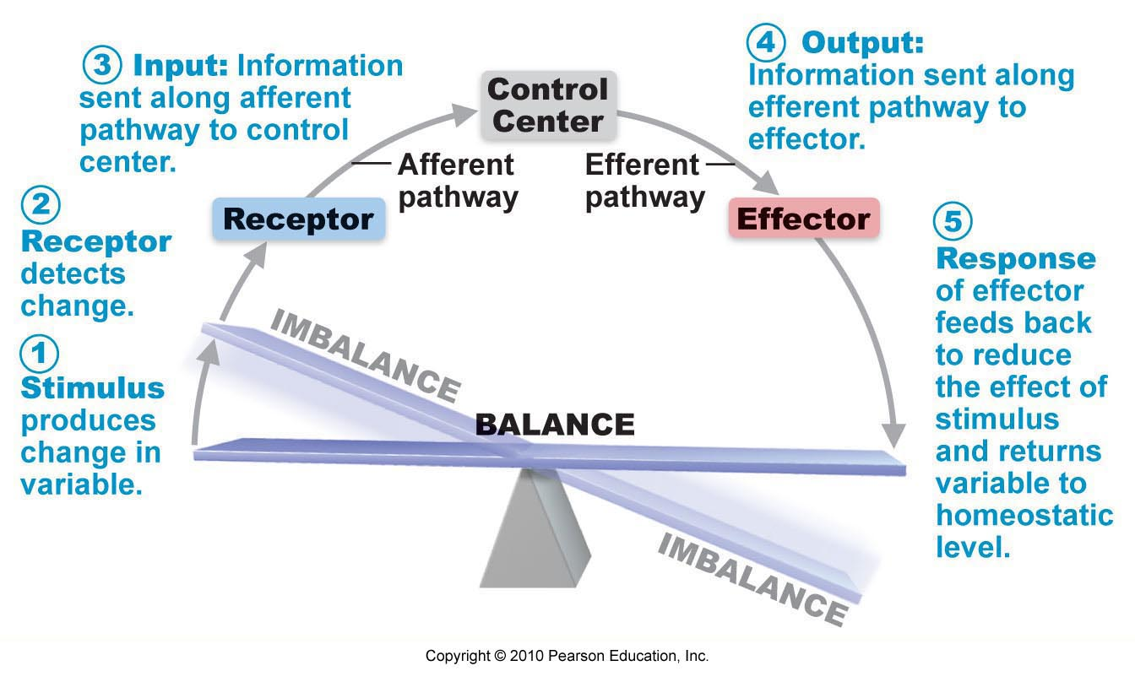
  - Three basic components
    - ___________________________
      - detects change in a variable (_______________/stress)
      - sends input (______________) to a control center
    - _____________________________
      - assesses input; sends output to effector(s)
    - _____________________________
      - causes response, i.e., an “effect” which is triggered by output
  - Negative Feedback Loop
    - Results in a return to homeostatic equilibrium because the response __________________ stimulus (stress)
    - Examples:
      - Regulation of blood _______________
      - Regulation of body _______________________
      - Most other physiological mechanisms
  - Positive Feedback Loop
    - Results in a shift to a new homeostatic equilibrium because the response __________________ the stimulus level (stress)
    - [“__________________ effect”]
    - Examples:
      - _______________________
      - _______________________/Childbirth
      - ______________________ responses
    - Most are responses to special conditions resulting in a ____________, _______________ physiologic state
  - _________________________________________
    - Pathological processes with a particular set of characteristics in which some or all parts of the body are not functioning correctly
      - _______________ or _______________ may be local or systemic
      - different systemic changes are present and may suggest a cause
        - ___________________ - subjective changes in body function, not observable; reported by the individual, e.g., pain
        - ___________________ - objective changes which are observable, e.g., temperature, pulse
- Anatomical Terminology: Anatomic terms describe directions within the body as well as the body’s reference planes, cavities, and regions.
  - Anatomical position: a constant ____________________ point
  - ______________________ terms: help you determine the exact location of a structure when navigating the body
  - _______________________ terms: used to designate body areas that have perform special functions
    - Axial
    - Appendicular
  - Directional Terms
    - _______________________: above
    - _______________________: below
    - _______________________: toward the front
    - _______________________: toward the back
    - _______________________: can be used instead of anterior
    - _______________________: can be used instead of posterior
    - _______________________: toward the body’s midline
    - _______________________: away from the body’s midline
    - _______________________: closest to the point of origin
    - _______________________: farthest from the point of origin
    - _______________________: lying face up
    - _______________________: lying face down
    - _______________________: (aka - Cephalic) toward the head
    - _______________________: toward the tail
    - _______________________: On the same side of the body or structure
    - _______________________: On the opposite side of the body or structure
    - _______________________: Closer to the surface
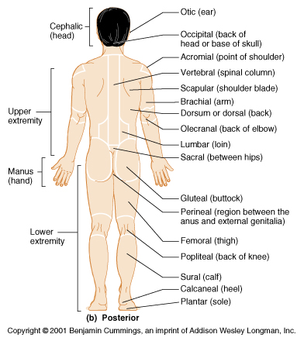
    - _______________________: Farther down below the surface
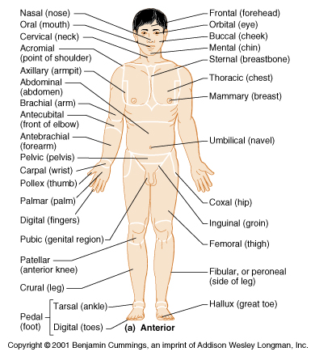
  - Anatomical Position

- General Organization of the Body
  - ____________________ Portion - head, neck, trunk
  - ____________________ Portion - arms & legs
  - 1. Several body cavities
2. Layers of membranes within cavities
3. Variety of organs and organ systems within cavities (_______________ = internal organs. "Visceral organs")
- Body Planes and Sections
  - Body Planes
    - Mid-______________ (Sagittal)
    - ________________________
    - ________________________ (cross)
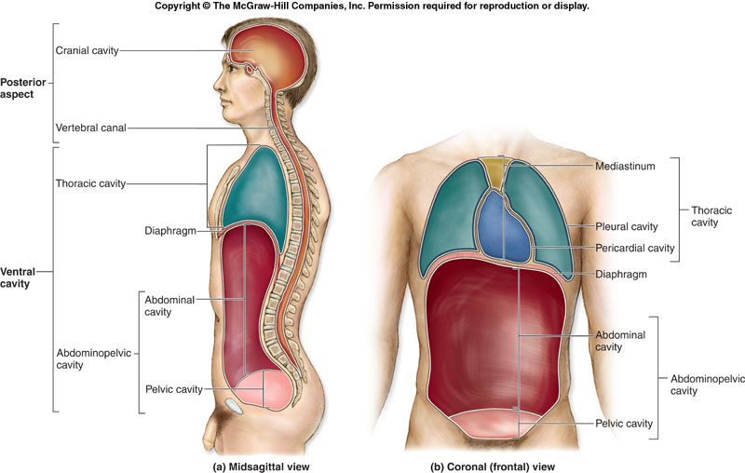
  - Body Cavities
    - Dorsal body cavity

    - Ventral body cavity
      - thoracic

      - Abdominopelvic

  - Other Body Cavities
    - ________________ cavity – mouth
    - ________________ cavity – located in the nose
    - ________________ cavities – house the eye
    - ________________ ear cavities – contain the small bones of the middle ear
    - ________________ cavities – within capsule around freely moveable joints
  - Membranes
    - __________________ Membrane - two layered, covers organs
      - Outer layer = ___________________
      - Inner layer = ____________________ (lines the organs)
    - ______________________ fluid – lubricating fluid
    - Pleura = ___________________
    - Pericardium = ________________________
    - Peritoneum = _____________________ (abdominopelvic region)
    - Membranes in the Ventral Cavity
      - Like a “Fist in a balloon”
      - Membrane inside a membrane with a narrow enclosed space in between
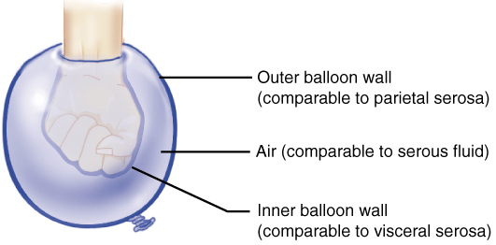
        - parietal
          - the outer membrane
          - on the ______________
        - visceral
          - the inner membrane
          - on the ______________
        - space
          - filled with watery fluid
      - Body cavity lined with serous membrane (_________________) which produces the serous fluid
      - Membrane named depending on its position, and the cavity’s organs inside
        - ________________________________ (layer around heart)
        - ____________________________ (layer right on top of heart)
  - 9 Body Regions
    - _____________________:
      - the area around the belly button
      - includes – parts of the large and small intestine, _____________ & abdominal ___________________.
    - ______________________:
      - superior to the umbilical region
      - includes – most of ________________, portions of stomach, _____________, inferior vena cava, & ____________________.
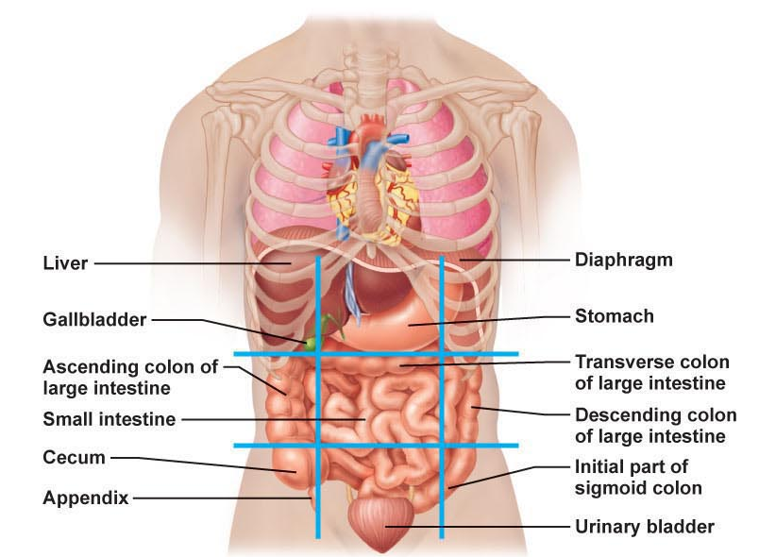
    - ___________________ (pubic):
      - inferior to the umbilical region
      - includes – urinary _____________, ureters, ____________ & ovaries (females).
    - Right & Left _______________
      - (__________________)
      - on either side of the hypogastric
      - includes – portions of the small and large _________________.
    - Right & Left ___________________ (__________________):
      - either side of the umbilical region
      - includes – portion of intestines and ______________________.
    - Right & Left ___________________________:
      - either side of the epigastric region
      - includes – ___________, _________, right side of liver, part of pancreas.
- TEN Organ Systems

ORGAN SYSTEMS
1. | Body covering.  Examples: Skin, hair, nails, sweat glands.  Function: protect underlying tissues and regulate body temperature
2. | Examples: Bones, ligaments, cartilage  Function: Support, movement, protection, and production of blood cells
3. | Muscles of the body  Examples: cardiac, smooth, skeletal  Function: Movement, maintenance of posture, production of body heat
4. | Examples: Brain, spinal cord, neurons, neuroglia  Function: Communicating stimuli, mental processing, maintaining homeostasis
5. | Examples: Ductless glands  - Pituitary  - Adrenal  - Thyroid  - Pancreas  - Ovaries  - Testes  - Thymus  - Pineal glands  Function: Secretion of hormones, communication between body parts
6. | Examples:  - Mouth, teeth, pharynx, esophagus, stomach, small intestine, large intestine  - liver, gall bladder, and many glands including the pancreas  Function: Breakdown of food substances into simpler forms that can be absorbed (digestion).
7. | Examples: Heart, blood vessels, blood.  Function: Transports materials throughout the body.  *_____________________ (#10) usually included with the circulatory system
8. | Examples: Kidneys, ureters, urinary bladder, urethra  Function:  - Removes ("filters") wastes from the blood  - helps maintain the body's water and electrolyte balance
9. | Examples: Reproductive organs, primarily the ovaries (females) and testes (males)  Function: Produce special reproductive cells for reproduction

- Historical Development of Anatomy and Physiology
  - Hippocrates
    - Father of _______________________
    - Attributed disease to natural causes rather than to the displeasure of the gods
    - ____________________: when blood, yellow bile, black bile, and phlegm were balanced, the person would be healthy and have an even disposition
      - Humor = _______________________
  - Agents in Metabolism – humoral theory
    - The Four Humors are the ________________________of the four elements in the human body.
    - The right balance and purity of them is essential to maintaining health.
    - The Four Humors and the elements they serve are as follows:
      - _________________ – AIR
      - _________________ - WATER
      - _________________ - FIRE
      - _________________ – EARTH
  - The Four Temperments
    - ____________________ : blood predominate
    - ____________________: too much yellow bile
    - ____________________: overproduction of black bile
    - ____________________: too much phlegm
  - Aristotle
    - First known account of ______________________
    - Described the development of a heart in a ______________ embryo
    - Established a type of ____________________________ for obtaining data
  - Erasistratus:
    - Father of __________________________
    - Interested in what caused diseases and disorders and what organs were affected
    - Some of his ideas were still based on __________________ concepts
  - Herophilus:
    - Criticized for the use of vivisection
    - _________________________: dissection of living animals
    - Described as a _________________ who had dissected as many as ________ living human beings, some of them in public demonstrations
  - Claudius Galen: (Roman Era)
    - Believed in the ___________________
    - _________________________
    - Explained nearly all bodily functions
    - Work contained MANY errors because he made conclusions regarding human functions on the basis of data obtained from _______________
  - Middle Ages
    - Dissections of _________________ were totally prohibited during this period
    - Examination by ____________________ and ____________________ were allowed for mysterious deaths
    - During the plague epidemic, a few necropsies were allowed in hope to determine its cause
    - ____________________: Post-mortem examination of a non-human animal
  - Renaissance
    - Characterized by a rebirth of _______________________
    - Vesalius
      - Father of ____________________
      - Challenged ____________________’s teachings
      - Beautifully ___________________ and described body systems and individual organs in a book
  - 17th and 18th Centuries
    - William Harvey
      - explanation of _____________________ flow
      - Father of ________________________________
    - Antoni van Leeuwenhoek
      - Development and use of the ____________________
      - Achieved magnification of ____________ times
      - View ___________ cells and striated appearance of _____________
  - 19th and 20th Centuries
    - __________________________
      - All living organisms are composed of cells and the products of cells
    - Anatomy and Physiology has become highly specialized due to the increase of ______________________

